Sample Press Release (this may be duplicated on your organization’s letterhead)

FOR IMMEDIATE RELEASE
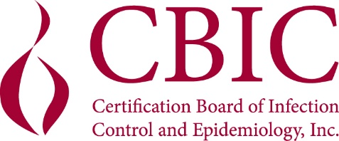

CONTACT: (Insert your organization’s contact)

(NAME) EARNS ADVANCED LEADERSHIP CERTIFICATION IN INFECTION PREVENTION AND CONTROL

Arlington, VA [Date] – CBIC has announced that (NAME), (TITLE) of (ORGANIZATION) has earned the Advanced Leadership Certification in Infection Prevention and Control (AL-CIP). The AL-CIP is an assessment of knowledge, skills and abilities of individuals who demonstrate
professional expertise, leadership and impact in the field of infection prevention and control (IPC). The AL-CIP certification is a portfolio-based assessment that recognizes expertise, leadership, and commitment to excellence in the field of infection prevention and control with criteria assessing the domains of leadership and professionalism. Candidates submit evidence demonstrating leadership within IPC that has a measurable impact. Through the portfolio-based approach, candidates provide evidence of their professional accomplishments, innovative practices, and leadership contributions to the field.

The Certification Board of Infection Control and Epidemiology, Inc. (CBIC®) administers the portfolio. The submissions are evaluated and scored by a team of subject matter experts in the field of IPC. Certification is maintained through successful resubmission of portfolio items and continuing education units every five years.

CBIC is a voluntary autonomous multidisciplinary board that provides direction for and administers the certification process for professionals in infection prevention and control and applied epidemiology. In 2023, CBIC celebrated 40 years of protecting the public through the development, administration, and promotion of certifications in infection prevention and control. For more information about CBIC, visit www.cbic.org.

###

